*Psycho* and the psychological theory

One of the most demented characters in cinema history is Norman Bates, the lead criminal in Alfred Hitchcock's *Psycho* (1960). Like a split personality, the film actually breaks into two distinct halves : the first is devoted to a perfectly normal law-breaker, Marion Crane, who is a secretary to an Arizona businessman. In the center of the film she crosses paths with Norman Bates, at which point, in a symbolic rape, he stabs her to death and *Psycho* becomes both the story of a mentally bizarre criminal, and a criminal investigation which masters the art of suspense.

1- the psychological theory

|  |
| --- |
| **Norman Bates : « A boy's best friend is his mother. »** |

*Psycho* illustrates cinema's power to show how a number of psychological factors can operate simultaneously to produce criminal behaviour.

a- psychoanalysis

According to Freud, the human psyche has three parts, the ego, id and superego. These parts constantly conflict with one another not just in offenders but in all people.

→ the ego : it represents reason and deliberation. It is the conscious aspect of the psyche.

→ the superego : It is one aspect of the unconscious, while the id forms the other. “Superego is always bombarding us with impossible orders, laughing at us when we cannot ever fulfill its demand. The more we obey it, the more it makes us guilty” (The Pervert’s Guide to Cinema, 2006).

→the id : It is driven by the desire for pleasure. It includes impulses, urges, and the libido or sexual energy.

Freud maintained that even small children have sexual impulses and that everyone experiences a desire -the Oedipus complex- to partner with the opposite sex- parent and kill the same- sex parent. Trapped between the id and the superego, the ego is almost bound to feel guilty, for it is constantly bombarded by demands from the id, which the superego must subdue. One result is defense mechanisms to which Freud gave names like repression, fixation, denial, and regression.

Freud himself avoided theorizing about crime and wrote only one short article on the subject, « Criminals from a Sense of Guilt » (1916), in which he speculates that some offenders, overwhelmed by a sense of guilt arising from the Oedipus complex, commit crimes in order to have something specific to be guilty about. Crimes are thus committed to « fix the sense of guilt », providing a sense of relief to the offenders.

Although Freud showed little interest in the cases of criminal behaviour, his theories provided very strong conceptual weapons for dealing with deviant behaviours. Today, psychoanalysis still offers some very deep and coherent insights of the personality of criminals, and the reasons why they committed crimes, however it is impossible to use it as a treatment to cure offenders or even to prevent them from committing a crime : how could governments possibly afford to psychoanalyse hundreds of thousands of lawbreakers ?

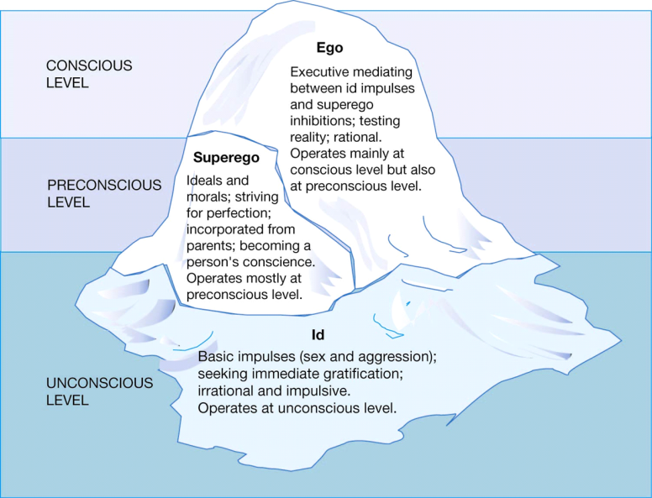



2- applying the theory to the film

At least 5 psychological themes appear in *Psycho*: split personality, voyeurism, sadism, guilt and self- punishment, and anal fixation.

a- split personality

This is the psychiatrist's diagnosis of Norman's mental pathology. According to him, Norman was « dangerously disturbed ever since his father died », and for years he and his mother lived together « as though there was no one else in the world »Then she met a man, and... He killed them both. », unable to bear the separation from the fusion his mother had built with him. To erase the heavy guilt of matricide, Norman stole his mother's body from its coffin and preserved it it as he did with his birds. Moreover, « he began to think and speak for her », developing a second personality.

Because Norman had been pathologically jealous of his mother, he assumed she felt the same way towards him. Thus, « if he felt a strong attraction to any other woman, the Mother- side of him would go wild ». Over the years, he (or she?) killed two young girls whose bodies would probably be found down the swamp, as the psychiatrist guesses. When he met Marion, he was sexually aroused by her, so « Mother killed the girl » and Norman covered up her crime. Now, however, the struggle between the two sides of his personality has ceased: Norman had become his mother, and this is obvious with the fade- out in the end of the film where Norman becomes his dead mother's skull.

b- Voyeurism

In the sexual disorder labeled voyeurism, someone derives erotic pleasure from secretely viewing others in intimate situations, including sexual activity. Voyeurism cannot be a onetime experience : to receive this diagnosis, the subject has to ogle repeatedly- to make a practice of sexual spying.

*Psycho* revels in voyeurism from its opening shot to the last. The film begins with the camera floating over the city of Phoenix, seeking exactly the right window through which to spy on a half- dressed woman – Marion- prone on a hotel room bed. Hitchcock links sex and peeking repeatedly but, with his usual subtlety, suggests that viewers too, make this association. The opening sequence establishes the equation of camera = voyeur = viewer. This equation is repeated when, with Norman, we peer through the peephole in the parlor wall to see Marion undressing. One may define voyeurism as sexual deviation, but, Hitchcock reminds us, it is a deviation that we as viewers, share with Norman.

The voyeurism theme is echoed in *Psycho*'s many mirrors, from the reflection with which Lila scares herself in Mrs. Bates' bedroom to the print in the parlor of Venus with a mirror. It helps explaining the film's ending, in which Norman locks eyes with us, the viewers, smiling over the secret he knows we share with him. We too, are voyeurs. If we didn't enjoy peeking, we wouldn't be still watching !



c- sadism

Sadism is the psychiatric term for sexual gratification obtained through hurting others, whether the hurt is physical or psychological. The term is often paired with masochism, meaning sexual gratification from pain : when a sadist's partner consents to the painful activity, he or she may be diagnosed as a masochist. The concept of masochism is an important tool for understanding the pleasure of movies. When viewers enjoy being terrified or take pleasure in watching pain inflicted on a character with whom they identify, their reaction may be described, figuratively, as masochistic.

In *Psycho*, we first identify with Marion, to whom Hitchcock devotes the first entire first half of the film so we can develop this identification. She is killed by a sexual sadist who stabs her repeatedly. To some degree, we experience the stabbing as Marion does ; the shower scene begins with viewers being (so to speak) with her in the tub as the camera first looks up at the showerhead, then out through the curtain to see the approaching figure. If Norman is the sadist, we then become the masochists ! This may be another reason why he smiles at us in the closing shot : he is on to our masochistic pleasure in vicariously experiencing harm.

Related but not identical to sadism is the sexual pleasure some people feel in viewing violence -or anticipating its appearance. The print on the parlor wall showing a male figure going after a naked woman alludes to this kind of gratification. When Marion arrives at the motel and Norman opens the window in her room, the blackness outside and curtain blowing inward create a creepy sensation of danger and vulnerability : anyone could be looking in. The open window and the print give us a sense of anticipation of the violence to come. The stuffed birds, too hint at violence, both the violence that was done to them when they were captured and the violence that they, with their sharp beaks, could inflict.



d- guilt and self- punishment

*Psycho* offers a devastating, if playful, study of guilt and its repression. Evidence of guilt sinks into the swamp behind the motel much as repressed memories sink into the subconscious. Guilt even has its own musical leitmotif : the opening theme, edgy, agitated, signaling dread. This guilt music recurs even when Marion feels simply guilty without good reason : the cop who awakens her in her car stares from behind dark glasses. She cannot see his eyes but his scrutiny, like that of a guilty conscience, makes her feel she has done something wrong by napping. His hidden eye will soon be echoed by Norman's eyes peeping through a hole in the parlour, Norman's eyes further echoing with our own guilt from enjoying such a violent movie in the end, with the gaze he exchanges with us in the last scene.

*Psycho* also is a film about the human capacity for self- punishment, the only way to deal with too much guilt. From the start, we feel that Marion will be punished, both for stealing the money and for extramarital sex in a hotel room in the middle of the day. She feels vulnerable to the cop because she knows it was wrong to steal the money. During her conversation with Norman in the parlor about how people find themselves in traps, she observes « Sometimes we deliberately step into those traps » Here she realizes that in fleeing with the money, she has set herself up for punishment- by herself, if not by others. The theft was self- thwarting behaviour. Similarly, Norman -punishing himself for matricide, his Oedipal lusts, his more ordinary lusts, and his voyeurism- encourages his mother to berate and mistreat him. He feels so guilty that, as Freud would have predicted, he represses his knowledge of his murders, fashioning for himself a split personality that can punish him and from which it is impossible to escape.

e. Anal fixation

“Psychoanalytic theory can also be useful to explain his other behavioral symptoms in the film. It becomes quite apparent that he is suffering from both anal & oral fixation problems. Bates’s continuous chewing habit and too many images of food depicts his oral fixation problem, that he has still remained his ‘mama’s boy’, depended on the mother-son bondage in one form or another. We can also explore some children’s toys in his room, which may indicate that he still plays with them. No direct depiction of anal fixation but it is subtle here, because the film includes a shot of a toilet bowl for the first time in fifty years in mainstream American films and also the Number plate of Crane’s car relates the word “anal”. Indication of Bates’s lack of hygiene when he says to the private detective that he doesn’t change the bed sheet of the motel room regularly also proves the notion of anal fixation.”

https://shonkhogrib.wordpress.com/2013/06/03/personality-of-norman-bates-from-psycho1960-a-psychoanalytic-approach/

Today the term *psycho* is almost synonymous with *psychopath,* but Hitchcock used it differently. The title of the movie signifies crazy, mad. Hitchcock's interest lies in investigating how a sweet young man could wind up psychotic. While Norman does kill a string of people – Mother and her lover, two young girls, Marion, Arbogast- Hitchcock doesn't portray him as a serial killer, someone whose key trait is a compulsion to kill. Rather, the director is curious about the many dimensions of Norman's pathology, the physical twists that have unhinged his mind. Norman's mind is like the old mansion in which he lives : multi-compartmentalized and decaying. It is also like his mother's body, another rotting form in which the psyche is trapped.

Another important thing here is the absence of the father. According to French Psychologist Jacques Lacan’s mirror image theory, oedipal process is the child’s entry into the world of language, into the symbolic order. Before that the child begins in a state of oneness with its mother which is the imaginary order. The imaginary order is the domain of the mother while the symbolic order is the domain of the father. In Bates’s case, the absence of the symbolic order, which is Bates’s father, leads Bates to go on living in the imaginary order. As Kolker & Phillip (2004) says, “ that Bates never left the imaginary order of mother and child in fact observed mother. Bates is always half mother and half Bates, a bisexual who has left both the real and symbolic realms behind, folded in on himself and become psychotic.”