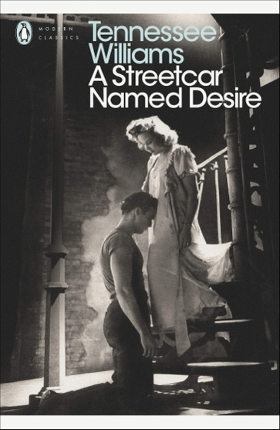 

Cover for the Penguin edition Paul Mescal (Stanley) and Patsy Ferran (Blanche) in a current production of *Streetcar*

Questions on the excerpt from Scene One (p.1-3 of the booklet):

**For each question, remember that you must answer by quoting the text and analysing your quotes.**

1. Pay attention to the first **stage direction** (l.1-6).

How would you describe this **setting**?

1. l.7-17: What impression of the neighbourhood do these first **cues** give us?

What comment can you make about the first **cue** specifically? Remember this is the **opening scene**.

1. What can you say about the characters’ names? About place names?
2. Explain what Stanley does in the passage from l.25 to 45.

Why do the two neighbours laugh?

What first impression of Stanley do we get through this? What does he remind you of?

1. Pay attention to the final **stage direction** describing Blanche (l.46-53).

What can you say about her outfit?

L.51-53: “Her delicate beauty…suggests a moth.”: analyse these two sentences.

**Vocabulary:**

* The **words in bold** are key words to write and talk about theatre. For your exam, you need to look them up if you don’t know them, learn them and start using them. Here’s the list:

A stage direction

The setting

A cue

The opening scene

* The words underlined are useful words to know and use for your own literary analysis. For your exam, I recommend you learn them and practice using them. Here’s the list:

It goes from line.x to line.x.

To pay attention to something

To give/produce an impression

A first impression

To remind somebody of something

To make a comment

A sentence (≠a phrase)

The final (=last) sentence

To associate something with something else