Séance 9: jeudi 4 avril - distanciel

- Correction of the American Dream Homework

- THEME 1: Ellis Island

- Read the introduction about Ellis island and the document below and try to reformulate it with our own words: what was Ellis Island? “immigration station”
- Ellis Island was a federal immigration station that opened in 1892. Mr Samuel Ellis was the owner of the island before and he gave his name to the immigration station. Through this station immigrants arrived in NYC after they answered 29 questions.
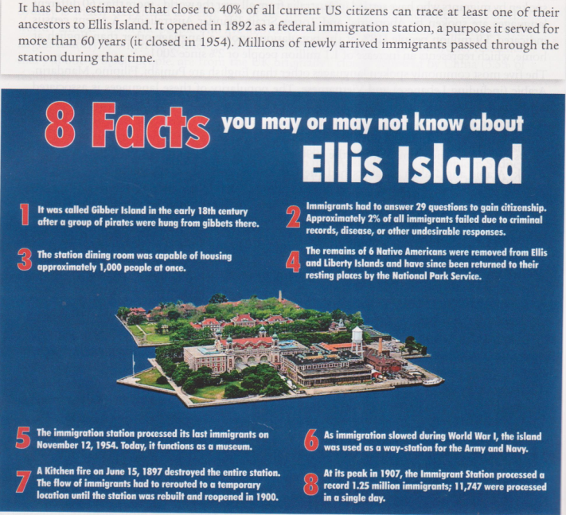
- Fill in the grids below:
- Pay attention to the numbers and their references and fill the grid +-Pay attention to dates and their references and fill the grid
DATES
1892 | the opening as a federal immigration station.
18 th century | gibber island was the first name
1897 | A kitchen fire destroyed the entire station.
1954 | last processing of the immigration
1900 | The immigration station was rebuilt after the fire.
1907 | Peak/record: 1.25 million immigrants
1954 | closing of the immigration station.
today | it’s a museum

NUMBERS
29 | number of questions asked to immigrants
2% | number of immigrants who failed the question and didn’t get citizenship
1000 | number of people that the dining room was capable of housing at once
6 | the remains of Native Americans that were removed from the island.
40% | current number of US citizens that can trace at least one of their ancestors to Ellis Island.
11747 | number of immigrants processed in a single day
1.25 million | in 1907: number of immigrants who arrived

- Thanks to all the information find these elements:

- what sort of reasons prevented people from being admitted ? People could not be admitted if they had criminal records, disease or undesirable responses/answers.
- What happened during WWI ? Immigration slowed and EI was used as a way-station for the army and navy.
- Which facts show that Ellis island is a very important place in American heritage ? The fact that today it’s a museum but also the fact that 40% of all current US citizens can trace at least one of their ancestors in Ellis Island.

3. THEME 2: An old culture
- Anticipate
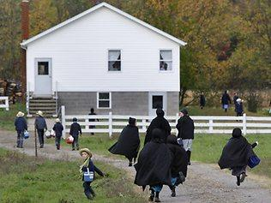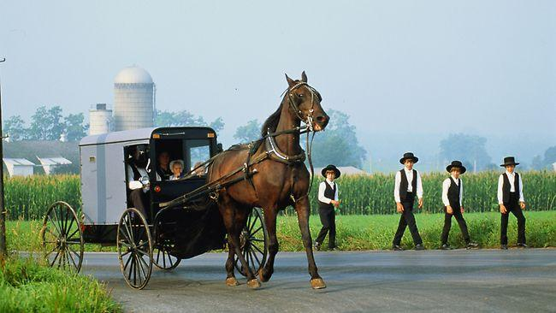
- Look at these pictures and describe what you see
- Do you think these are recent or old pictures?
🡪look at the children on the first picture, they are holding a modern object find what is it?
- Can you guess their origins/culture/country?
- Do you have any information about them?
On these 2 pictures, we can see children dressed in the old ways. On the right Pic they Are ridding a carriage with a horse like locomotion as they used to before.
It’s probably recent because we can See in the back of the right picture a building with material from today and in the left pic children are holding coolers. They must be Amish or Mormons, communities exclusively in the usa. They live in oldways because of their religious beliefs and don’t Mix to the Rest of the population.
The 2 photos are recent and show a community of persons who live with the ancestral coutumes. They refuse modernity, but in the first photo the child has an isothermal bag. The name of this community is the Amish. The origin of these people is German.
In these images you can see Amish people, the photos are recent. They live in a community and keep to themselves. They are cut off from today's world, living as they did in the old days.

- Reading and understanding
The Amish: Last updated 2009-06-23. Partially based on The Amish In Northern Indiana, by Samuel L. Yode
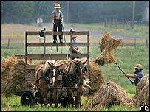
Who are the Amish?
On the surface, many Amish look like they stepped out of the rural 19th Century.
The most conservative, Old Order groups of these reclusive, religious people drive horses and buggies rather than cars. Many have no telephones or electricity in their homes. They send their children to private, one-room schoolhouses until the age of 13. They eschew technology and preach isolation from the modern world. They do not join the military or accept assistance from the government. The Amish community in Lancaster County, Pennsylvania was a model for the 1985 film Witness starring Harrison Ford, a thriller which contrasted the violent modern world with their peaceful existence. The Amish experience many of the same problems as other communities, but keep them private.
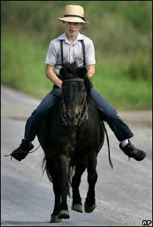
Strict regulations:
Some 200,000 Amish people live in more than 20 US states and in the Canadian province of Ontario. The oldest group of Old Order Amish, about 16,000-18,000 people, live in Lancaster County, a rural, farming area where Amish first settled in the 1720s - many fleeing religious persecution in Europe.
The Amish are divided into dozens of separate fellowships, broken down into districts or congregations. Each district is fully independent and lives by its own set of unwritten rules, or Ordnung.
Men and boys wear straw broad-brimmed hats
The Old Order are the most conservative of these groups, and observe strict regulations on dress, behaviour, and the use of technology, which they believe encourages humility and separation from the world. Old Order Amish women wear modest dresses with long sleeves and a full skirt, a cape and an apron. They never cut their hair, but wear it in a bun on the back of the head. Men and boys wear dark-coloured suits, straight-cut coats and black or straw broad-brimmed hats. They grow beards only after they marry. Modern technology is not rejected out of hand. Some farms have telephones and local groups can allow electricity to be used in certain circumstances.
Most Amish are trilingual. They speak a dialect of German called Pennsylvania Dutch at home, use High German at their worship services, and they learn English at school. In some ways, the Amish are feeling the pressures of the modern world.
- Read the text and fill in the grid with all these elements : location/number/language/reason of immigration/religion
Location: | Number: | Reason for coming to the USA | Language:
Lancaster County, Pennsylvania  - USA  - Canada | 200,000 Amish people live in more than 20 US states and in the Canadian province of Ontario  16,000-18,000 people, live in Lancaster County | many escaped religious persecution in Europe in 1720’s | Most Amish are trilingual. They speak a dialect of German called Pennsylvania Dutch at home, use High German at their worship services, and they learn English at school.

- Find all the elements related to their relationship with new technology/the modern world (in blue)
- Find all the elements showing their conservative features/believes (in purple) (focus on adjectives for that)
- Find all the elements related to their dress code and their appearance in general (in green)

- Writing about a subject
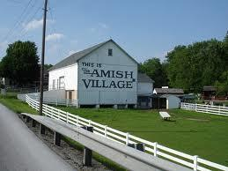
You are a journalist for a school newspaper. You are writing an article about life in an Amish village. You were invited to spend a day there. Write an article about your experience.

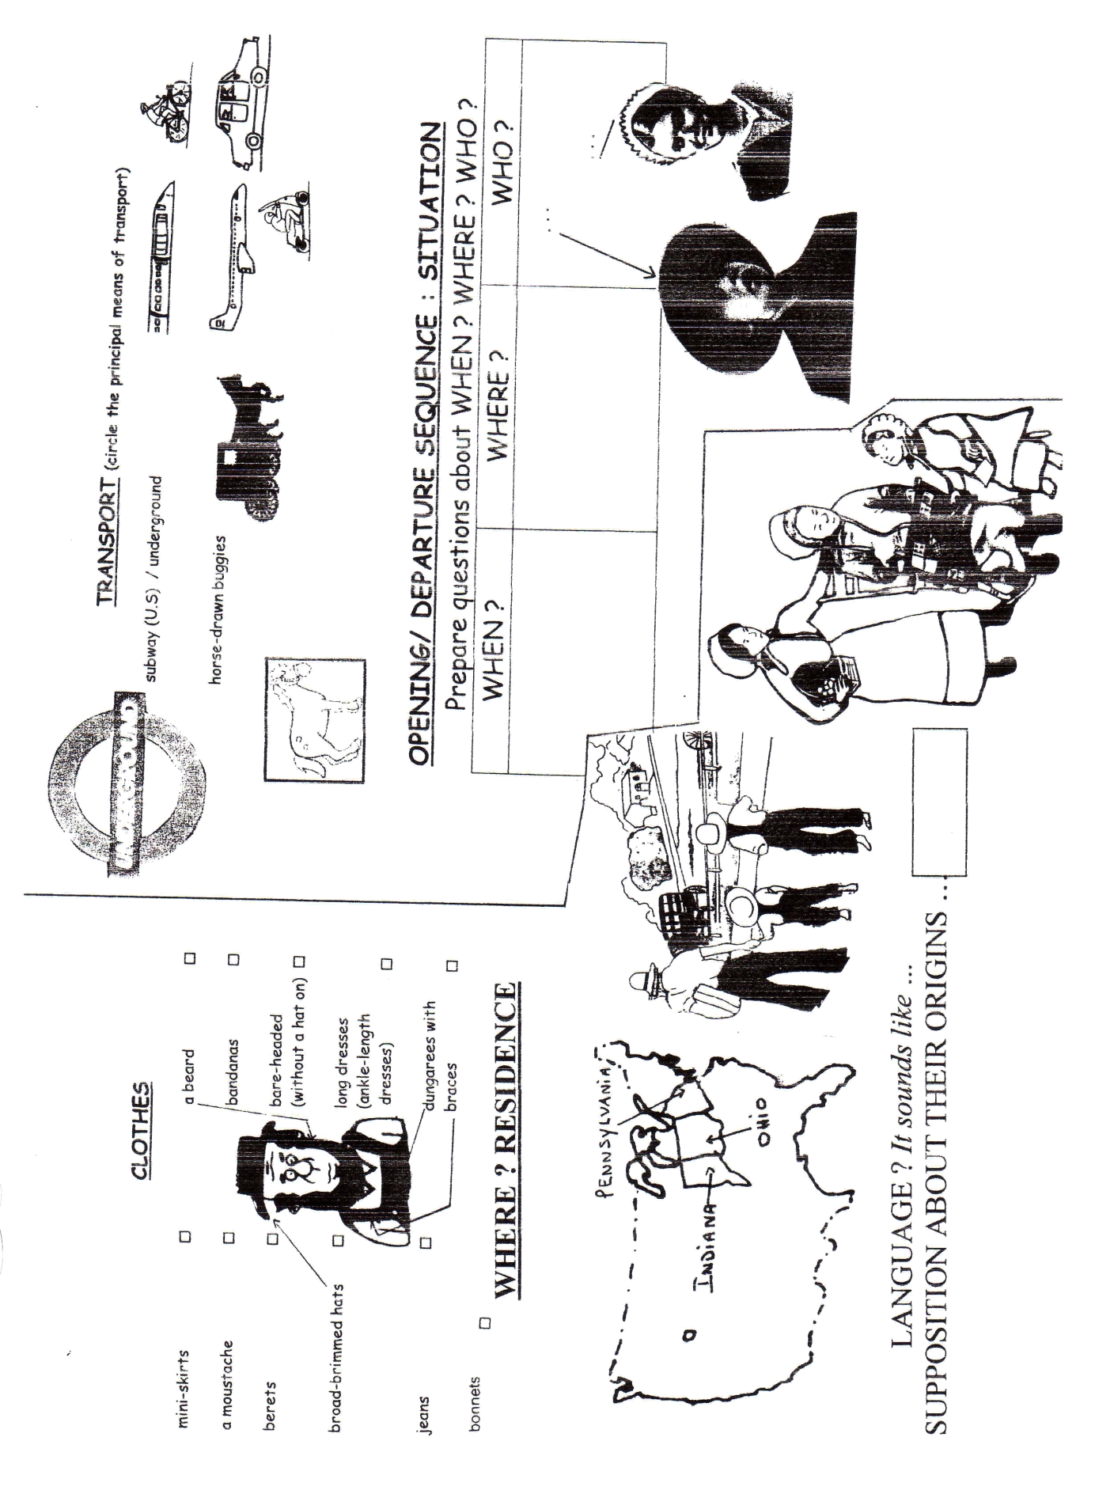

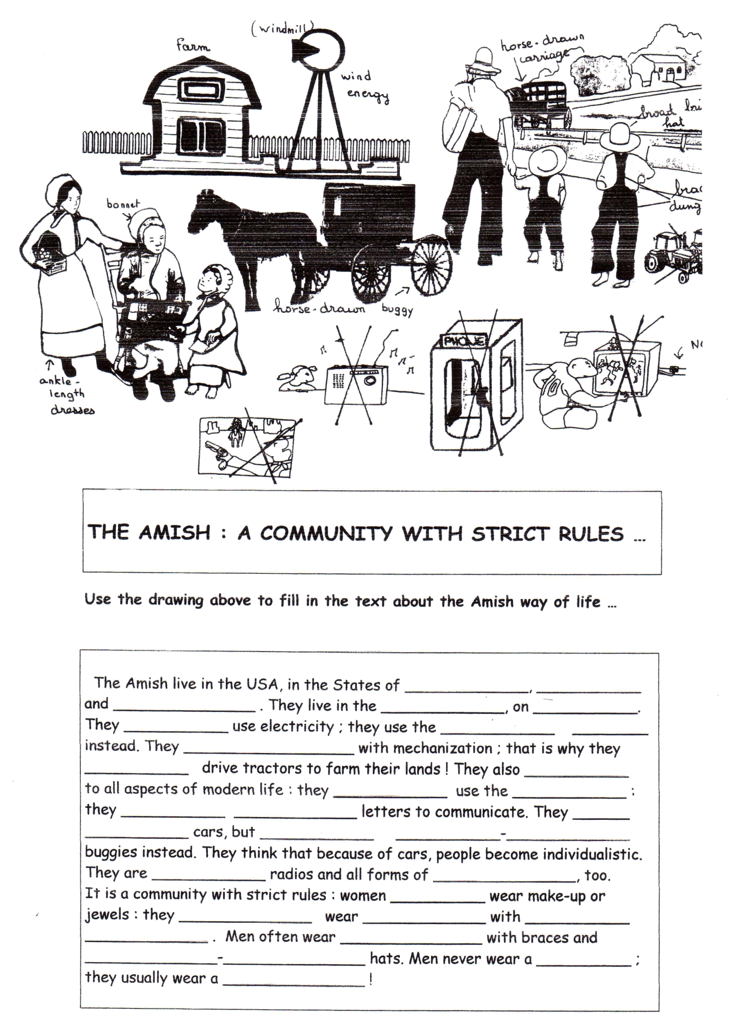
Compare our society to the Amish Comunity

 | Our society | The Amish community
Transport
School
Languages
House equipment
Hobbies/pastimes
clothes

https://www.youtube.com/watch?v=skn_rRdDHnA
Amish Youth Experience Internet During Rumspringa
1. Present the document and the subject:
3. Try to find the following information thanks to the stress words and to the images in the video.
🡪 What can you see? (words or expressions/characters/places/actions/feelings)

🡪 Forbidden activities for the Amish

🡪 The definition of Rumspringa

🡪 Find out what they should they decide at the end of their Rumspringa

🡪 Find what are the risks during Rumspringa

4. What would be your choice? What would you do:
- I would rather …..
5. According to you, what could be the reason for Rumspringa for the Amish community?

