THE AMERICAN DREAM

- Production écrite

Compare Steve’s vision of the American dream to the first immigrants at Ellis Island. Find at least 4 arguments to compare them. Find one argument that proves that America is still a dream country.
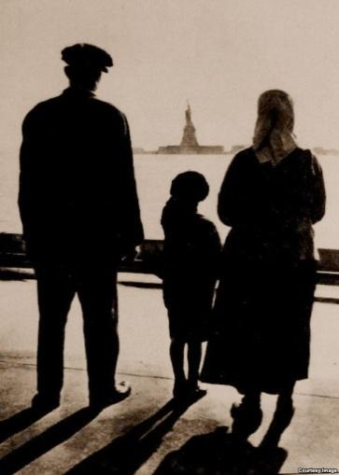

- Compréhension écrite : Lisez le texte ci-dessous et répondez aux questions.
We asked well-known locals of all colors to talk about what diversity really means in 2008.
What does multiculturalism mean in New York? Are we a melting pot or a salad bowl?
Parker: “New York has always been a melting pot that didn’t melt. Take, for example, the Korean fruit markets: We buy fruit and vegetables from these markets. It would make sense that we should know something about the history and culture of Korea. The people working at these stores can do much more than sell fruit.”
Brown: “A mosaic or melting pot implies that there is an integration that I don’t think is true in the city.”
Kweli: “New York City is not a true melting pot, but the outer boroughs are, especially Brooklyn. As the largest borough, we have Russians, Trinis, Italians, Puerto Ricans, Israelis, Palestinians, Jamaicans and everyone else living side by side.”
Iyer: “Demographically, New York is more of a mosaic, without question. All over New York you see many different immigrant communities that are large enough that they can maintain a semblance of their cultures. On the other hand, Queens is a truly multicultural borough, one of the most diverse places on the planet, and you see more people interacting across these boundaries of nation and culture.”
Yosef: “The possibility for an immigrant to have the freedom to be himself and to implement his own identity and culture makes it a melting pot.”
Q-Tip: “It’s more of a mosaic. Slowly but surely, the neighborhoods are starting to mix. For example, in Harlem, a lot of white people are moving in, but they don’t interact with the locals too much. It creates a neighborhood within a separate neighborhood. So now there’s Harlem and there’s white Harlem.”
Can we truly call ourselves diverse if we stay separated?
Q-Tip: “No, we can’t. The only way diversity is achieved is through the intermingling of people.”
Iyer: “As far as I’m concerned, separate coexistence is not a huge problem as long as we have some semblance of equality.
Naison: “We’re constantly borrowing one another’s food, music, language, and ways of walking, talking and dressing. The creation of hybrid cultural forms and styles is a constant feature of New York life.”
Posted: Tuesday November 4 2008. THE NEW YORK ONLINE.

Questions:
1. Present the document (use the method seen in class).
2. What is the document about ?
4. Comment upon the title (the tone which is used)
5. Pick out the questions asked to these people.
6. Pick out the answers of the people and find their arguments.

- Debate:
DO YOU THINK THAT FRANCE IS A SALAD BOWL OR A MELTING POT ? FIND AT LEAST 3 ARGUMENTS

