L3 Sciences de l’éducation Cours d’anglais Shân Williams S1 2023-4 Group B

L3 Sciences de l’éducation S1 2023-24
shan.williams@u-picardie.fr Bureau E116
En complément aux cours vous pouvez travailler dans le centre de ressources langues E118 ou participer aux activités et cours ponctuels ou réguliers organisés par la Maison des Langues.
https://www.u-picardie.fr/services-communs/mdl/bienvenue/

Si vous faites 15 heures d’activités supplémentaires dans le cadre des propositions de la Maison des Langues vous pouvez valider vos efforts sur un passeport Maison des Langues et obtenir un point bonus sur votre moyenne d’anglais. (Nautilus, CRL, activités ponctuels) Si vous suivez un cours supplémentaire vous avez 0,1 sur la moyenne générale. (C1 Citadelle mardi 9H-11H, A2 Citadelle mardi 10h-12H, A2+/B1 Mercredi Citadelle 9H-11H, autres cours jeudi après-midi aux Minimes) Vous avez aussi la possibilité de passer le TOEIC ou Linguaskills. Certifications payantes mais utiles pour votre C.V Sur le ENT vous trouverez les activités à distance qui peuvent être validés Nautilus Les inscriptions aux cours complémentaires se trouvent sur le ENT pratiques valorisées.

Vous devez tous faire les activités sur le page moodle (même si vous êtes dispensés d’assiduité.) Vous y trouverez aussi les documents du cours.
https://pedag.u-picardie.fr/moodle/upjv/course/view.php?id=929
Pour contacter Mme Williams utilisez votre adresse courriel UPJV et indiquez votre année spécialité et groupe.

A la fin de l’année il y a un test de niveau et une attestation avec votre niveau d’anglais du cadre européen commune de référence. Ceci peut être demandé pour des candidatures en Master. Master Meef International demande un niveau B2 par exemple.

Evaluation Niveau européen /12
 | A1 | A2 | B1 | B2/C
Production écrite/ orale | Capable de produire de très courts message sur soi et son environnement proche  /1 | Capable de produire des messages simples sur thèmes quotidiens  /4 | Capable de produire des messages, factuels et descriptifs, ou en lien avec des intérêts personnels  /9 | Capable d'exprimer et de nuancer son opinion, de produire des messages complexes sur des thèmes divers /12
Points du cours /8
 | Non acquis | En cours d'acquisition | En bonne voie | Acquis
Références culturelles au monde anglophone |  | 0,5 | 1 | 2
Points linguistiques (structures grammaticales) |  | 0,5 | 1 | 2
Réinvestissement du lexique |  | 0,5 | 1 | 2
Articulation et cohérence du discours (style, aisance, connecteurs, …) |  | 0,5 | 1 | 2
TOTAL: /20

Class 1
Disability brainstorming
To be disabled/to have a disability (avoid handicapped/handicap)
We will brainstorm vocabulary together. A mindmap will be on the moodle after the first class. Think of adjectives to describe disability, equipment needed, official medical terms, problems faced by the disabled, words not to use.

The word disabled comes from the verb to be able to/to not be able to do something

Personal experience
First watch ‘Ticket without a seat’. Retell the story.
Discuss:
Do you know anyone who is disabled?
Have they been disabled from birth or have they become disabled?
What problems do they have? What help do they need?
Have you ever helped someone who is disabled?/had a good friend who is disabled?/seen examples of discrimination?
What help is given in schools to disabled pupils? Did you have any disabled pupils in your class or when you have been doing teaching observation and practice?

Watch a video about a partially sighted boy called Theo and take notes.(link on the moodle)
Disability

Details of the disability

What he/she can/can’t do

Special needs/help

Interests, likes, dislikes

Friends and family

Message/qualities

Write a text in groups to describe a typical day in the life of Theo.(After the class you can see a simple B1 level example on the moodle)_______________________________________________________________________________________________________________________________________________________________

Famous People With Disabilities Quiz
This exercise lists famous people whose names and accomplishments are probably familiar to you. However, you might not know that they are or were a person with a disability. The individual is listed by their accomplishment in categories.
Match the person in the first column with his/her disability in the second column. Draw a line between the person and their disability.

Actors and Actresses
Name | Disability | Pronunciation
Marlee Matlin | Diabetes | Dia’betes
Danny Glover | Cerebral Palsy
Geri Jewell | Down’s Syndrome
Ben Stiller | Stutter
Tom Cruise | Deaf
Mary Tyler Moore | Dyslexia
Halle Berry | Parkinson’s disease
Bruce Willis | Bipolar Manic Depression
Chris Burke | Epilepsy
Michael J. Fox | Diabetes

Musicians
Name | Disability
Ludwig van Beethoven | Blind
Ray Charles | Deaf
Stevie Wonder | Depression, Alcoholism
José Feliciano | Blind
Billy Joel | Depression, Drug Addiction
Kurt Cobain | Spina Bifida
John Cougar Mellencamp | Multiple Sclerosis
Alan Osmond | Blind

Homework
Now follow the instructions on the Moodle section 1. You must do all the activities there, before the next class in 2 weeks. Your teacher will check that you have done the work and you need the work for the next class.

Class 2 (half the class for one hour the other hour is for the Moodle work.)
Make groups and tell the others about your video and the charity which helps. Take notes.
 | Archie | Phoebe | Alexandra | Robbie
Disability
Details of the disability
What he/she can/can’t do
Special needs/help
Interests, likes,
dislikes
Friends and family
Message/qualities

Cerebral palsy. SCOPE Archie

Diabetes. Diabetes UK Phoebe

Downs Syndrome. Mencap Alessandra

Epilepsy.UK Robbie

Homework
As a preparation for class 3 learn about Paralympic sport by doing the test your knowledge quiz on the Moodle. Follow the instructions for a written homework to be posted on the moodle. No translators please!

Class 3 L3 S1
What it means to be superhuman.
You are going to watch some of the biggest names in paralympic sport from the GB team at Rio discuss what the word ‘disability’ means to them.
Complete the table with their sports and disability
Sam Ruddock (SR)
Libby Clegg (LC)
Hannah Cockcroft (HC)
Richard Whitehead (RW)
David Weir (DW)
Cody Rayer’mum (CRM)

Who said?
‘The word disability doesn’t bother me at all”
‘There’s thousands of words that can describe me and disabled is just one of them’
‘I’ve just got a disability and I’m very able in what I’ve got’
‘Despite their stories they can do incredible things’
‘Superhumans is a fantastic way to describe people from all different backgrounds with all different types of ability.’
‘To me the word disability is just a describing word, it doesn’t describe me fully’
‘Yes he can do these sports. He can get out there. He can do it’
‘Disabled or amputee to me, it doesn’t make a rat’s arse.’
We are the superhumans

Did you watch the Paralympics? Did you see any tv commercials related to the Paralympics?
Listen to the song ‘Yes I can’ and write the text.
___________________________________________________________________________________________________________________________________________________________________________________________________________________________________________________________________________________________________________________________________________________________________________________________________________________________________________________________________________________________________________________________________________________________________________________________________________________________________________________________________________________________________________________________________________________________________________________________________________________________________

A commercial was produced for the Rio Paralympics by channel 4 and seen by 11 million viewers .140 disabled people took part. It contributed a lot to the increased interest in the Paralympics. The video is available in different versions such as audio description for the blind or partially sighted.
Now you are going to watch with images and in groups write as many sentences as possible to describe what superhuman things people in the video are doing.

Here is some sports and music vocabulary.
An archer, a tap dancer, arrow, to shoot, fencing, to do the high jump
A pianist, a guitarist, a drummer, a cellist,

Example
A drummer with no arms (who is)) drumming with his feet.
_______________________________________________________________________________________________________________________________________________________________________________________________________________________________________________________________________________________________________________________________________________________________________________________________________________________________________________________________________________________________________________________________________________________________________________________________________________________________________________________________________________________________________________________________________________________________________________________________________________________________________________________________________________________________________
TED TALK.
There are lots of Ted Talks about disability. We are going to watch one together.
The sore problem of prosthetic limbs
(adapted from Keynote Upper Intermediate,Unit 7)
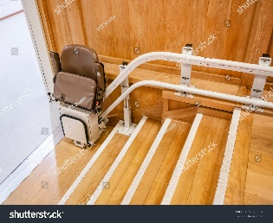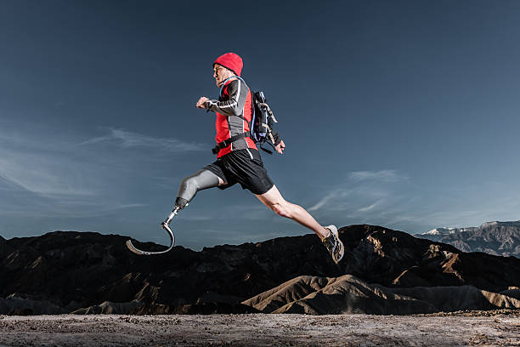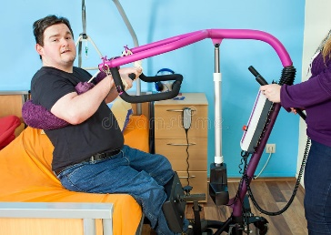

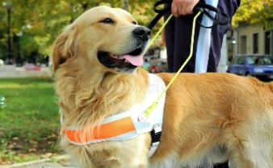
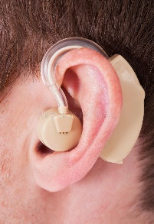
Match the pictures to the equipment, which helps disabled people.
wheelchair prosthetic foot ramp hoist seeing dog/guide dog crutches hearing aid stairlift
Look at this picture of Hugh Herr. What do you notice ?
Vocabulary amputee and prosthetic limb
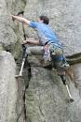

At the age of 17 Hugh Herr was one of America’s best climbers. In 1982 he had to have his two legs amputated after an accident and severe frostbite. A few months later he began climbing again and he studied biophysics at MIT (Massachuchetts Institute of Technology) and began to do work on leg prostheses.
You are going to watch a Ted talk about David Sengeh from Sierra Leone. Growing up there, he was aware that many people had lost limbs during the civil war and he became involved in research at MIT to improve prosthetic limbs using technology.

Key Words
Match the meaning with the definition.
- A prosthesis takes the place of a missing limb for amputees.
- A patient who can’t change the position of their body easily can get pressure sores.
- The magnetic resonance imaging (MRI) scan showed where my leg was broken.
- When a person’s arm comes out of their shoulder socket it’s quite easy to put back in place.
- Patients who have to spend a lot of time in bed find that pillows can make them more
comfortable.
- Paraolympic atheletes compete in sports classified by their disability

A an artificial part of the body
B a type of medical technology that takes pictures of the body
C soft cushions
D painful damage to the skin
E a cup-shape device that another part fits into
F a physical or mental condition that can affect the way a person functions.

Watch the Ted talk ’The sore problem of prosthetic limbs’ without the subtitles.
https://www.ted.com/talks/david_sengeh_the_sore_problem_of_prosthetic_limbs?language=en

T/F
David was a young man during the civil war. T/F
Many people who had suffered amputation couldn’t afford prosthetic limbs. T/F
The prosthetic limbs available in Sierra Leone, were painful to wear. T/F
While he was doing his PhD, David developed a solution to the prosthetic problem. T/F
The sockets he made are expensive to make. T/F

Watch the Ted talk’The sore problem of prosthetic limbs’

Watch again and complete the summary 0 .00-2.20

acceptable | as a result of | before
easy to | find | didn’t fit
make | promised himself
- About 8000 men,women and children were amputees [[__________________]] the war in Sierra Leone.2. David Sengeh [[_____________________________]]that he would contribute to a better future for his country.3.The main problem with prosthetic limbs was that they [[__________________]]4. It can take years for an amputee to [[_____________]] a prothesis that is comfortable.5. Davis Sengeh thought that conventional uncomfortable prosthetics were not [[______________________]]in today’s world.
2.20 -3.45
Put the events a-e in order.
A He got very positive feedback from a recent trial.
B. They discussed solving the problem of painful sockets.
C. He produced the sockets with a 3D printer.
D He met Professor Hugh Herr a researcher and amputee,who still continued climbing.
E He used medical technology to look at individual patients.
3.45 to the end
What is the message of his talk ?
What technological innovations need to be developed or installed in France to make life easier for disabled people ? What are the difficulties which disabled people face?
Choose the meaning of the word in italics.
1.One of the things that troubled me was that many amputees would not use their prostheses.
A angered
B pleased
C worried
- If your prosthetic socket is uncomfortable , you will not use your leg and that is simply unacceptable in our age.
A almost
B sadly
C totally

- He asked me if i knew how to solve the problem.I said,’No,not yet, but i would love to figure it out.’
A calculate the cost
B find the answer
C help you with it
Homework
Now follow the instructions on the Moodle to prepare class 4 and to make a short recording to post on the Moodle. For class 4 you must prepare to present a Ted talk to the class relating to disability. in your own words. The class will be divided into groups, one hour each. Short presentation of 2/3 minutes. Only key words on the board/power point / a paper to be used. So that you choose different subjects please post your choice on the Moodle.

Who is the person? What is their disability? What challenges have they faced? What is their message?
Homework
At home on the moodle page study the video and do the exercises relating to gerunds and infinitives.

Class 5 L3 S1
Gerunds and infinitives

Verb plus infinitive
Modals
I must work harder
I can see her
I would rather go home
plus object
He let her go home
he made me work hard
BUT IF YOU CHANGE TENSE with modals !!
He won’t be able to come
He had to leave
Plus ing

Strong emotions
like, love, hate, enjoy, can’t stand and many other verbs too !

I can’t stand/I don’t like listening to loud music

Plus to
Many verbs such as hope, want ,manage
He managed to open the door
He had hoped to go to university

Some verbs both are possible with or without a change in meaning
I remember /forgot seeing him(about a past event)
I remembered to/forgot to buy the bread(intention)
I need to buy a computer(personal)
My computer needs repairing (by someone else)

Vocabulary
to manage
to pretend
to give up
sell by date
to fancy
to be worth
to carry on
to look forward to

Manage to | Worth + ing
Practise =+ing | Needs +ing
Pretend to | Tried to
can’t stand + ing | imagine +ing
Risk +ing | Rather read
Give up + ing | Mind + ing
Tend to | Remember +ing
Let you + V | Make you do
Forget to | Carry on+ing
fancy+ing | Look forward to +ing
Recommend+Ing  can’t help + ing | Prefer to

Student A
Complete the sentencewith the correct form of the verbs in brackets.
A Ask your partner the questions
Answer B's questions and discuss.
- Could you manage for a week without your phone? (live)
- Do you ever get the chance to practise English outside class? (speak)
- If you really hated your friend's partner, would you pretend■ him / her? (like
- Is there any kind of housewor k you can't you stand ? (do)

5 What kind of things do you tend about? (worry)
6 Did your parents let you in the street when you were a child? (play)
7 Do you sometimes forget things or do you have a good memory? (do)
8 Is there a city or country that you really fancy ? (visit)
9 Are there any apps you'd recommend ? (get)
10 Is there a TV programme you can't help_________ even though you don't think it's very good? (watch)

Student B
Complete the sentence with the verb in the correct form. Ask your partner the questions and discuss.
- Do you think it is worth______________a yearly medical check up? (have)
- Is there anything that really needs _________________to your house or flat or room?(do)
- Have you ever tried___________________flatpack furniture?(assemble)
- Would you rather_______an e-book or a paperback book?(read)
- Are there any jobs in the house that you don’t mind____________?(do)
- Do you remember _______________your best friend for the first time?(meet)
- Have you ever had to stop ____________a food for health reasons?(allergy etc)(eat)
- Do you think you will carry on ___________English next year?(study)
- Is there a film you are looking forward to __________?(see)
- Would you prefer ___________a week in the country or by the beach?(spend)

Ted Talk
What happens when you have a disease doctors can’t diagnose?
Jennifer Brea
https://www.ted.com/talks/jen_brea_what_happens_when_you_have_a_disease
_doctors_can_t_diagnose
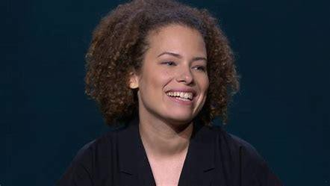

Pronunciation
Medical words are often fairly transparent, but difficult to say. Examples
Myalgic encephalomyelitis M.E Chronic Fatigue Syndrome Encéphalomyélite Myalgique(EM), Syndrome de Fatigue Chronique (SFC).
Put the following medical words that you will hear in the Ted Talk, in the correct stress patterns.
Specialist metabolism hypochondriac neurologist dermatologist endoctrinologist cardiologist psychiatrist muliple sclerosis epilepsy inflammation
° neurological
°
°
°
°
°
°
°

Part one 0.0-6.31 Complete the table with notes about Jennifer Brea

Name | Jennifer Brea
5 years ago she was
Her first health problems were

What did the neurologist think were the causes and what did he diagnose?
What happened when she walked home and after?
What did she then discover?Note the numbers and statistics

Now compare your notes with a partner.

Part two 6.31-9.20

She researched what the neurologist thought was wrong with her ‘conversion disorder’ and discovered that this was previosly called hysteria.She discovered that for centuries people like her were thought to be hysterical.Later Freud had developed an idea that physical symptoms could be caused by painful memories and emotions.People with M.E have frequently (and sometimes still are) been

given psychological explanations. In the past this was the same for epilepsy and multiple sclerosis.

Part three 9.20-10.05 and 11.06_-12.09 Complete
The US spends $ per year per patient on Aids, $ on MS and
$ on M.E.
Since the 1950’s rates of autoimmune diseases have to

% of patients are initially told they are
% of patiens are

12.09 -14.27
Jennifer has hope because progress has been made in the diagnosis and treatment of epilepsy and MS. Some research is now being done into M.E and patients themselves are helping one another and sharing information and experiences.

Part four 14.27-end
Read the conclusion. Try to guess the missing words. Check by watching the video.

I came together with p around the w and we started to f .We have filled the v with something
w but it is not_e . I still don’t know if I will ever be a to r again or walk any d or do any of those k things that I only do in my dreams. But I am so
g for how far I have come.P is slow and it is
and down, but I am getting a little b every day.
I remember what it was like, when I was s in that bedroom, when it had been m since I had seen the sun.I thought I would d there.But here I am today with you and that is a m _____
Homework
Before the final class you must do the timed online quiz about the gerunds and infinitives and can and to be able. In the final class we will finish watching the film ‘Unrest’. There will be some writing to do.If you miss the class, you will have to come to the CRL to watch the film

